How to register with webAIRS

or check your existing registration
- From the webAIRS landing page, click one of various registration links
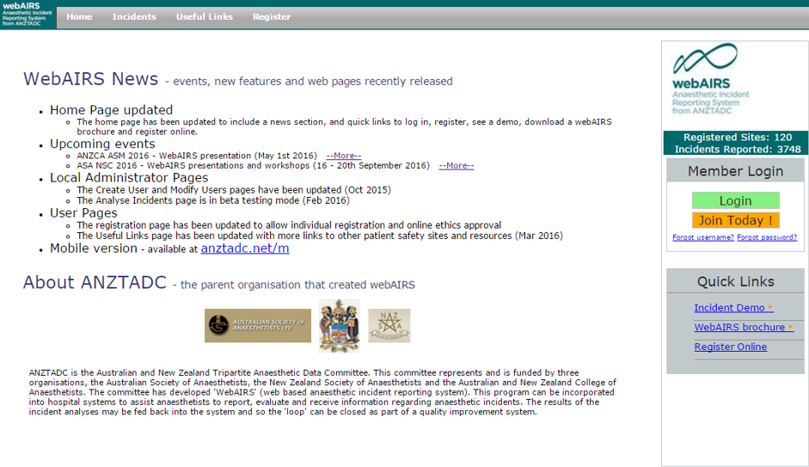

- To proceed, a captcha number will need to be entered into the labelled box
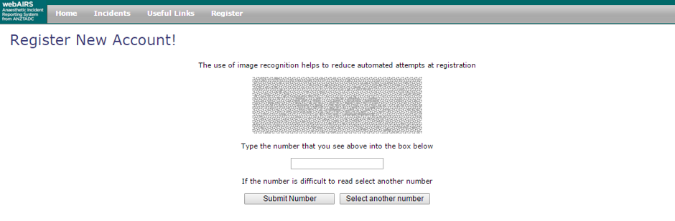
- Select the appropriate option from the menu. Each pathway is explained below.
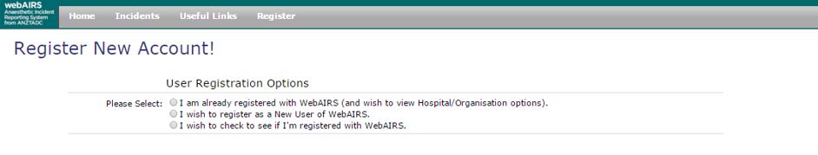
Option 1 – I am already registered with webAIRS (and wish to view Hospital/Organisation options).
- You will be asked to enter your email address.
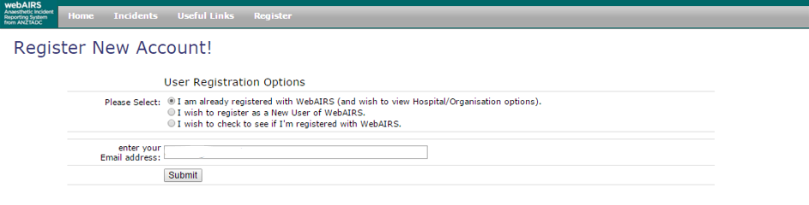
- Upon submitting, the regular log in page will need to be completed
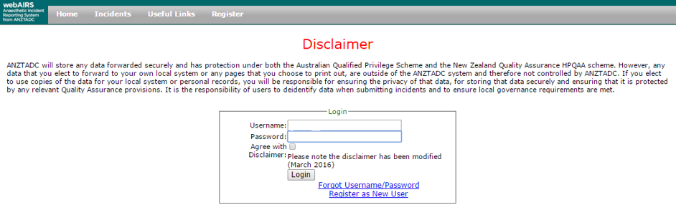

- Your options for linking to a site will then appear. Note that organisations or sites already linked will be listed in green.
- For next steps, see “Linking your registration to a site” on page six, below.
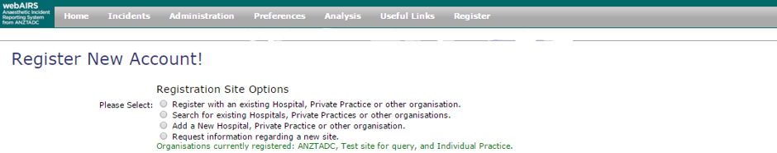
- Note, the fourth option, above, to “Request information regarding a new site” expands to read as follows:

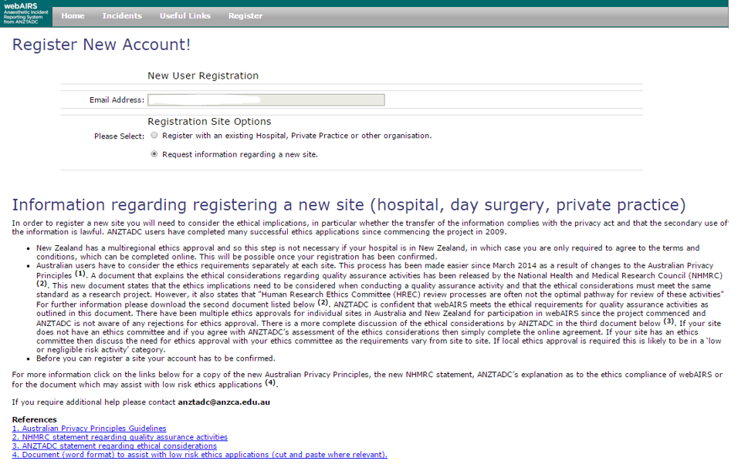
Option 2 – I wish to register as a new user of webAIRS
- A new registration page will need to be completed. You will then be prompted to agree with the user terms and conditions and ethical considerations (note: the full version of these documents can be accessed via the blue link, as per below)
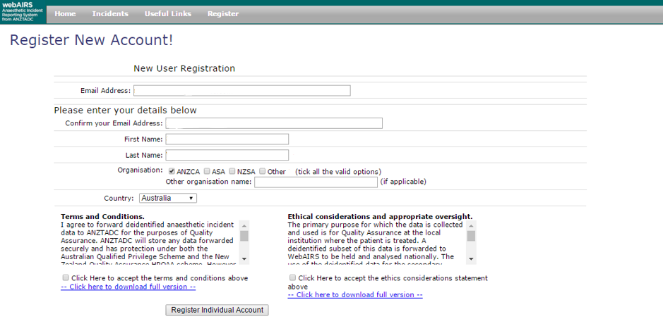

- Clicking “Register Individual Account” will allow you to complete your registration. You can then link to an existing site(s)/organisation, set up a new one or remain as an individual and unattached user in webAIRS (listed as “Individual Practice”)

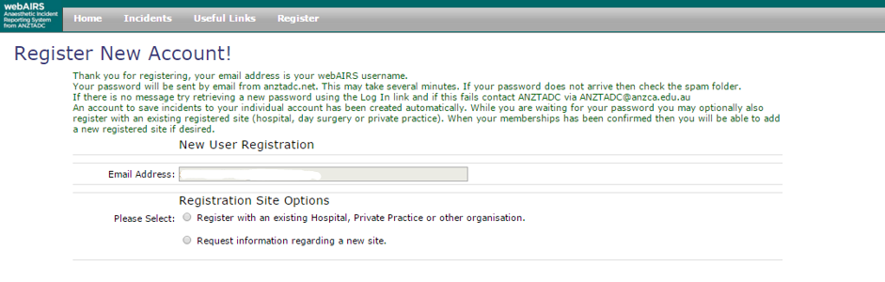
- For next steps, see “Linking your registration to a site” on page six, below.

Option 3 – I wish to check to see if I’m registered with webAIRS
- You will be asked to enter your email address
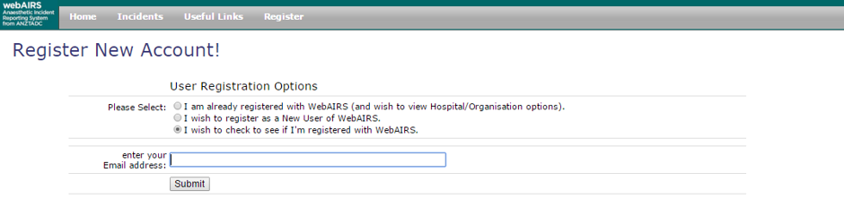
- If you are a registered user of webAIRS you will be informed and prompted to progress to the log in page.
- If you are not registered, you will be prompted to register as a new user
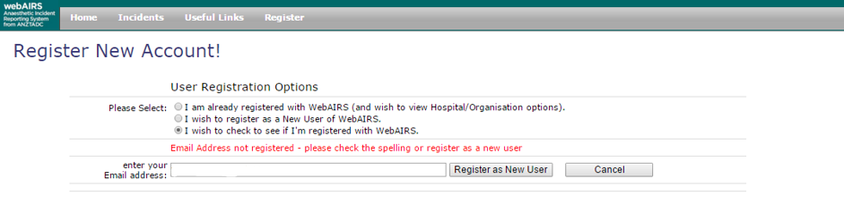
- For next steps, see “Option 2 – I wish to register as a new user of webAIRS” see pages three and four, above.

Linking your registration to a site
Linking to a site allows you to contribute to local data collation and have your incident included in analysis functions. Data remains anonymous whether entered as an individual user or as someone linked to a site.
- Four options exist when wanting to link your registration to a site.
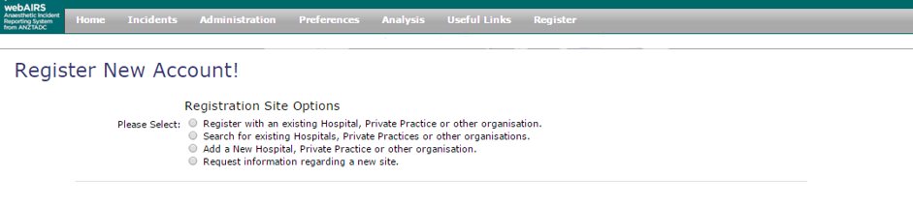
Option 1 – Register with an existing Hospital, Private Practice
or other organisations
- By making various selections from the drop down options, relevant sites/organisations will be offered for you to link to.
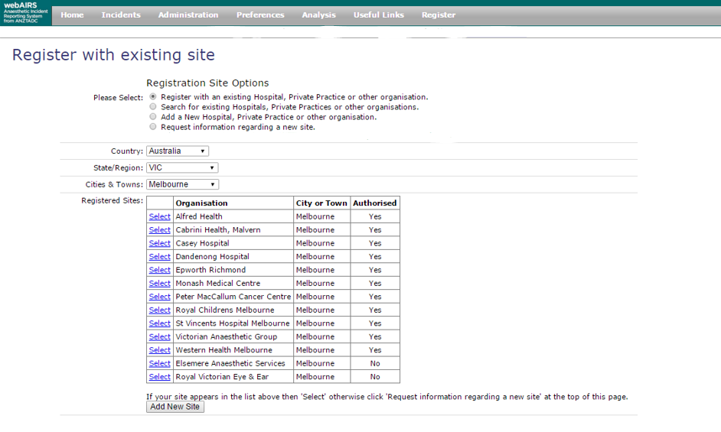

Option 2 – Search for existing Hospitals, Private Practices
or other organisations
- Selecting “search for existing Hospitals” will take you through the same process as above with the option of linking any of the organisations that a search may bring up
- Following selection of a site, the Local Administrator will need to approve the linking

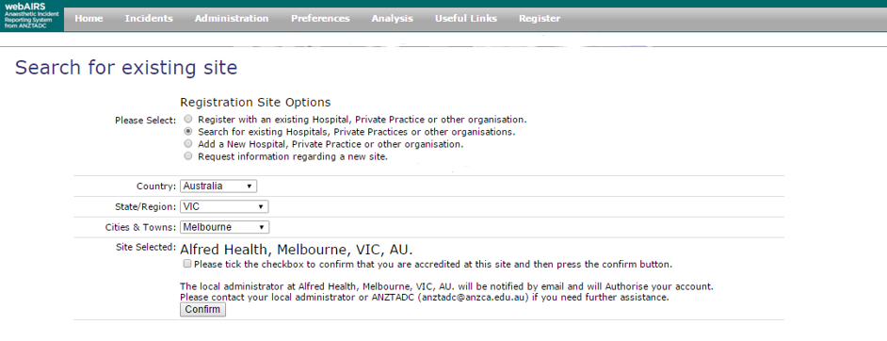
Option 3 – Add a new Hospital, Private Practice or other organisations
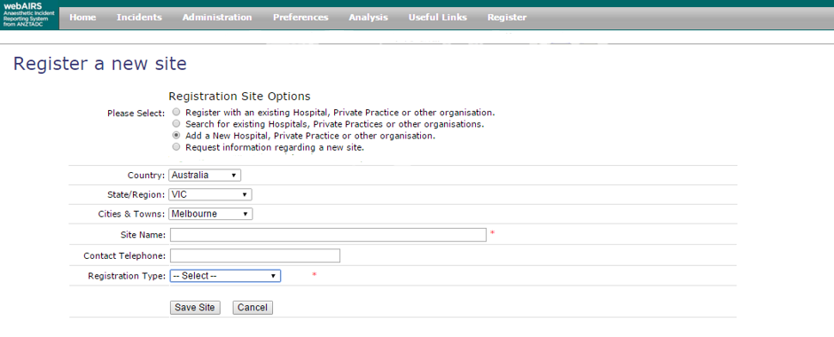
- Following the completion of the above online form, ANZTADC is required to authorise the registration of a new site – this process may take up to three days

Option 4 – Request information regarding a new site
- The fourth check box option expands to give the following information:
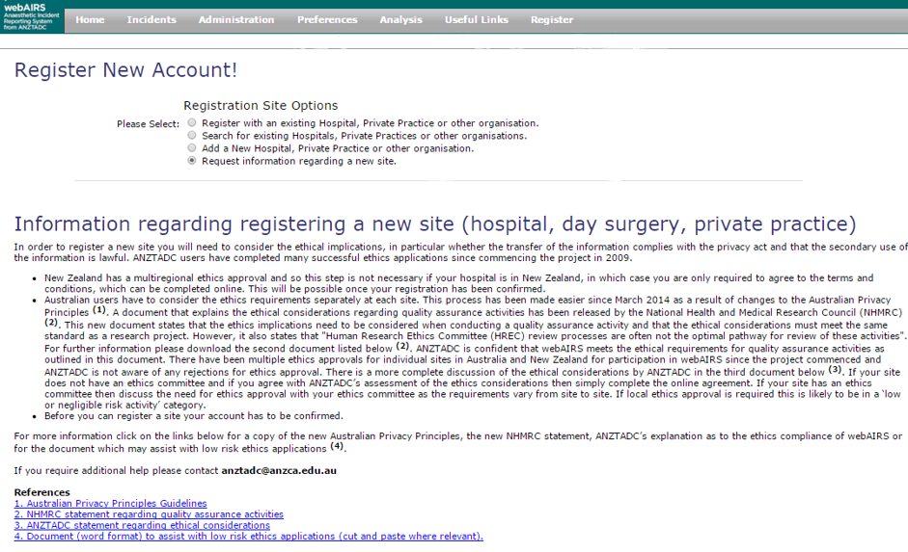

- For any assistance with registration or further information please contact ANZTADC@anzca.edu.au

Version: 1.3
Updated: 17 May 2016

